
School Prospectus 2026-2027

Our Mission Statement
We follow in the footsteps of Jesus.

This is a Good Catholic School. Parents, pupils, staff and Governors say that the school is a loving, caring school which has helped to form children into healthy, happy and confident individuals.

Section 48 Inspection February 2025
“Pupils are extremely eager to learn and this contributes to how well they get on with their work and the successes they achieve. They treat others with great respect and behave outstandingly well. Relationships are excellent; this is the result of the highly caring principles of the school and the very good example set by the staff.”
“Pupils are happy and enjoy their learning. The school’s virtues are at the heart of this community. Pupils talk confidently about how they ‘follow in the footsteps of Jesus’. Pupils are kind and show care towards each other. They feel safe and know how to stay safe, whether online or in the local community.”
OFSTED 2025
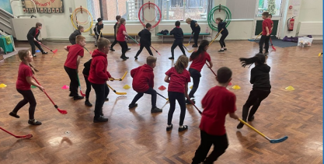

St John the Evangelist Catholic Primary School - Home

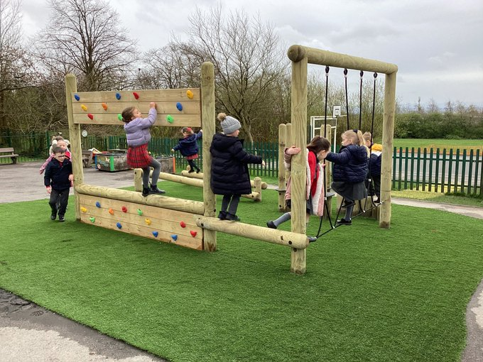
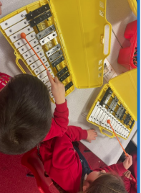
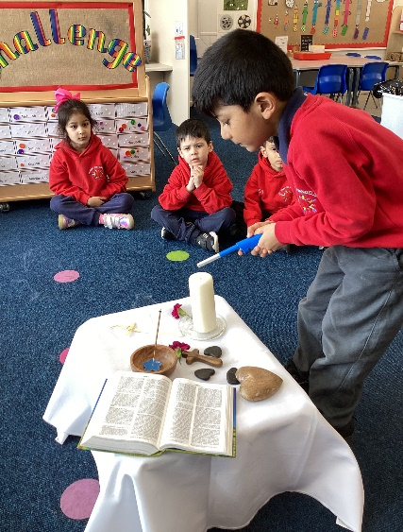


Contents: Page:
Our School | 3
School Information and Mission Statement | 6
Aims and Our Governing Body | 7
The Staff | 8
Our School Day | 9
Curriculum | 10
SATs and Assessment | 14
Parent Consultations | 14
Special Educational Needs | 14
Homework | 15
Reading with Your Child | 15
After School Care Club | 15
Educational Visits | 16
Breakfast Club | 17
School Dinners | 17
Free School Meals | 18
School Uniform | 20
Absence from school | 21
Attendance | 22
Holidays | 22
School Milk | 23
Fruit and Vegetable Scheme | 23
Behaviour Policy | 23
Security around School | 24
Parking around School | 24
Things we need to know | 25
Arbor messaging | 25
Medicine in School | 25
Accidents/First Aid | 26
Fundraising | 26
Complaints Procedure | 26
Statutory Information | 27
School Calendar | 28
Disclaimer | 29
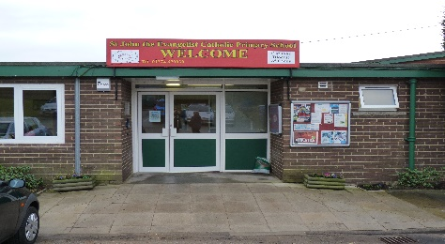
Our School
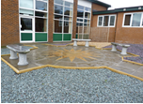
St John the Evangelist is a Catholic Primary School situated within the parish of Mary Mother of God. As a Catholic school we develop and nurture our faith through regular liturgies and assemblies, and the celebration of Mass in both the school and the parish church. We see our school as rooted in a wider faith community and seek to establish a close liaison between all members of our community.
In October 2016 the school became a voluntary academy and we are part of the Blessed Christopher Wharton Catholic Academy Trust within the Catholic Diocese of Leeds.


Religious Celebrations and Worship

The celebration of the Mass is central to the life of our faith community, and we have a liturgical calendar of masses and liturgies which run throughout the year giving our children many opportunities to take part in Mass so that they can ask God for his blessing and give Him thanks and praise. We expect the parents of our Catholic children to ensure they take their children to Mass each Sunday. We welcome our new families into our parish community at a Welcome Mass in the autumn term and celebrate in our Parish church masses during the year, both at St John the Evangelist Catholic Church, Cooper Lane and in our school. We ask that all our families take these opportunities to celebrate Mass as a community in our Parish Church.

Partnership
We are conscious that educating our children is a partnership shared between home, parish and school, and we encourage parents to take an active role in our school.
We have Open Mornings twice a year in November and June so that parents and members of the local community can come in to school and see us in action, and we also warmly invite parents, families and friends to our masses, liturgies, and weekly assemblies.
We have consultation evenings twice a year when parents can discuss with the teacher their child’s progress, but staff are always willing to meet with parents to discuss any issues which may have an impact on your child’s school life. We hope our partnership with parents/carers will be one of sharing – a sharing of information, knowledge, experiences and decision making about our children’s growth, social development and academic progress.
Clear communication is essential to ensure that parents and carers are kept informed about school events so that they can plan times when they can come in to school and share in a range of celebrations.
A school newsletter is sent via Arbor app to parents each Friday and is also available on our website. This gives details of upcoming events in school and is an important document.

We also use our text messaging service via Arbor to remind parents and carers about events in school also we reward positive behavior within school and good work achieved through messages sent to parents and they are also mentioned at the weekly celebration assemblies for the stars of the week awards – we have been told by parents that they value these messages to alert them to what is happening in school!

Our school website www.sjtebcw.greenhousecms.co.uk has a wealth of information for parents to access, including newsletters, policies and key information.

We invite our new parents and carers to spend an evening with us in school in June, before the children start in September. Some of the teaching and support staff attend this evening, together with representatives of our governing body. They are there to help you get an understanding of life at St. John the Evangelist, and to answer your questions.
All the staff at St John the Evangelist work very hard to provide a nurturing environment where every child is encouraged to fulfil his/her potential and we welcome and encourage parent/carers help and support both in school and at home.

Blessed Christopher Wharton Catholic Academy Trust
In October 2016 we became a voluntary academy and we are part of the Blessed Christopher Wharton Catholic Academy Trust. There are 17 schools in the Trust and we work in partnership and strive to provide an outstanding Catholic education.

The core principles of the Blessed Christopher Wharton Catholic Academy Trust are:

The Trust and each academy within the Trust will adhere to the following principles:

- The search for excellence

Our education is, primarily, about “human flourishing.” It is concerned with the development of the whole person. The aim of Catholic education is to draw out of all people their God-given potential to enable them to fulfill their unique role in society. All involved in the Trust will promote this for the benefit of the young people in our care.

- The uniqueness of the individual, made in God’s image and loved by him.

- The education of the whole person, based on the belief that the human and the divine are inseparable.

The education of the whole person not only enhances the dignity of the individual, in the long term it promotes the common good in society and in the world-wide human community.

- The education of all, with the particular duty to care for the poor and disadvantaged.

- Moral Principles.
In the multi-academy trust, the trustee directors and all academies have a moral responsibility for the good of all schools within the trust.
Solidarity means we are all responsible for each other. No school or college is an island entire of itself:
“Our schools, not my school.”
At the heart of the Church’s social teaching is the duty to care for others. This is a founding principle of our Multi Academy Trust.

Many of our children move on to our Partnership Secondary School, St Bede’s and St Joseph’s Catholic College, to continue their Catholic Education and we do everything we can to make transitions to all Secondary Schools as easy as possible for every pupil.



School Information
Executive Headteacher:  Interim Head of School: | Mr Ben Lavin  Mr Fawcett
School Address: | St John the Evangelist  Catholic Primary School  Beacon Road  Bradford  BD6 3DQ
Telephone: | 01274 679030
E Mail:  Website:  Instagram: | office@sje.bcwcat.co.uk  St John the Evangelist Catholic Primary School - Home (stjohntheevangelistrc.co.uk)  St_john_the_evangelist
St John the Evangelist is a one - form entry Catholic primary school. It caters for 210 pupils of 4 – 11 years old


Our Aims
- To nurture and stimulate each child’s faith and provide opportunities for this expression through worship and prayer.
- To foster loving relationships between all members of our school community and promote and reflect the command of Jesus, “Love one another as I have loved you.”
- To encourage everyone to be a thoughtful, confident, well motivated and responsible member of God’s family.
- To encourage everyone to achieve their created potential by providing a curriculum which is broad and balanced in order to interest and engage all pupils, and challenge them to do their best.
- To foster self-esteem by encouraging pride in their achievements.
- To lead children to respect and appreciate the environment in which they live.
- To encourage cooperation and collaboration between individuals and groups and so create a genuine sense of community.
Academy Council:
As we are an academy our Governing Body is an Academy Council and the Academy Trust Board has overall responsibility for all schools in the Catholic Academy Trust. The Academy Council has a general responsibility for supporting our school, ensuring that it provides the best possible education for our pupils and acting as a critical friend to the Headteacher.
On 7th January 2021 both St Winefride’s Catholic Academy LAC (Local Academy Council) and St John the Evangelist Catholic Academy LAC joined to make one joint Local Academy Council (Governors). This joint council will oversee both schools.

All Governors serve a four-year term of office from the date of appointment. The Governing Body meets twice a term. Parents can contact the Parent Governor to discuss any issues which they may wish to be included at a Governors meeting.

Chair of LAC: | Mrs K Naik
Vice Chair: | Mrs M Bannister
Foundation Governors: | Mgr P Grogan  Ms M Karas
Staff Governors: | Mrs C Furniss
Parent Governor: | Mrs E Hanney
Clerk to Governors: | Mrs V Bettson
Executive Head: | Mr B Lavin

Any correspondence for the Governing Body should be addressed to ‘Chair of the Governing Body’ c/o the school address.

The Staff

Executive Headteacher: Mr B Lavin

Interim Head of School: Mr S Fawcett

School Business Manager: Miss M Corley

School Administrator: Miss K Lister

SENDCO: Mrs A Walker

Reception: Mrs A Greenwood (Teacher Reception/EYFS Leader)
Mr M Fairclough (Teacher Reception)

Key Stage 1:

Year 1: Mrs H Dawson (Teacher Year 1)

Year 2: Mrs S Campbell (Teacher Year 2)

Lower Key Stage 2:

Year 3: Miss A Rashad (Teacher Year 3)

Year 4: Mr D Hudson – Crook (Teacher Year 4)

Upper Key Stage 2:

Year 5: Mrs L Williamson (Teacher Year 5)

Year 6: Mrs Johnson (Teacher Year 6)
Mrs C Crowther (Teacher Year 6)

Teaching Assistants:

Mrs T Ashraf
Miss K Fox
Mrs J Haley
Mrs A Simpson
Mrs K Timewell
Miss Smith
Miss Ahmed
Mrs Zafar

Lunchtime Supervisors:
Miss K Fox
Mrs J Hornby
Mrs A Allsopp
Miss Lister
Miss S Baker
Mrs Simpson
Miss Smith
Mrs Zafar
Miss Ahmed

After School Care Club: Miss Lister
Miss Ahmed

Caretaking Team: Mrs G Dixon
Mrs C Stones
Mrs C Taylor

Catering Unit Manager: Cater Link

Our School Day:
Our school day starts at 8.55am and finishes at 3.15pm when the bell goes. We would ask you to support your child’s learning by ensuring regular and punctual attendance each day.
8.45am School opens
8.55am | School starts
10.30 – 10.45am | Morning Break
12.00 – 1.00pm | Lunch time
3.15pm | School finishes
Doors are open from 8.45am for the children in Reception to Year 6 to enter school. At 8.55am the doors are shut and children have to be brought to the main entrance.
Under no circumstances should children be left at the main entrance before 8.55am. The main car park must not be used to drop children off. NO cars apart from staff, should be in the school car park.
The registers are taken at the beginning of each morning and afternoon session. The bell goes for the start of the day at 8.55am. Any child who arrives after 8.55am (the cloakroom doors locked) must be taken to the main entrance to ensure he/she is registered correctly. And must not be left to come into school by themselves.

Children arriving after 9.00am but before 9.30am will receive a late mark. Children who arrive after 9.30am will be marked late after registration which counts as an unauthorised absence from school.

As a school we want all children to reach their full potential and therefore feel it is essential that they attend each day and arrive punctually at 8.55am ready to start the school day.

If there is an unavoidable reason for your child being absent or late for school please telephone the office before 9am and advise them what time your child will arrive, or the reason for absence. Persistent latecomers will be referred to the Headteacher, who will contact the parents and, if necessary, report the situation to the Education Welfare Officer.
We encourage and promote daily attendance unless a child is ill or there is a good reason for their absence.
We work closely with our Education Welfare Officer who is able to offer parents advice on attendance, and is willing to make home visits if there are any concerns.

Collection of children at the end of the school day:
School finishes at 3.15pm and ALL children should be collected at that time unless they are participating in one of the various After School Clubs, when they should then be collected by 4.30pm prompt. If your child is collected late from the afterschool club 2 or more times you will be charged £10 per child.

If for some reason you are delayed on your way to collect your child, please contact the School Office on 01274 679030. We do keep a note of times and dates that children are collected late and you will be contacted if there is a persistent problem. Children in Reception and Key Stage 1 and Lower Key Stage 2 must be collected by an adult from their classroom door. Children in Upper Key Stage 2 are allowed to go home on their own if parents so wish, providing written permission has been provided by parents.

Children are kept in class until 3.25pm when they are then taken to the After School Care Club in the dining room. A charge of £4.00 is incurred for children collected after 3.25pm.

Curriculum
In organising our curriculum content we have identified four basic needs:
- To be mindful of our distinctive Catholic nature.
- To address the needs of the children at St John the Evangelist
- To meet the requirements of Curriculum Guidance for the Early Years Foundation Stage
- To meet the requirements of the National Curriculum
When children start school we aim to help them build on all reading, writing, mathematical and scientific skills they have already gained. Children are gradually introduced to more formal activities involved in learning to read and write and develop their mathematical and scientific capabilities. Children are encouraged to become more independent and, as they progress, to take on more responsibility for their own learning.
Our curriculum delivery is supported by our classroom organisation which is as follows:
Early Years Reception  Key Stage 1 | Reception Class  Year One  Year Two | 4/5 years  5/6 years  6/7 years
Lower Key Stage 2 | Year Three  Year Four | 7/8 years  8/9 years
Upper Key Stage 2 | Year Five  Year Six | 9/10 years  10/11 years

Religious Education

We aim to help our children to grow to love God and to know how much they are loved by him. We follow “The Way, the Truth and the Life” R.E. programme.
Monsignor Paul Grogan is our Parish Priest and he leads us in all our school Masses and many of our liturgical services within school throughout the year, and we invite parents to join us for Masses and liturgies. Liturgies and prayers are planned regularly in each class and base, parents and carers are invited to join us to share these special reflections to support and celebrate with us your child’s spiritual development. During the year each class base will study one of the world religions to enable them to understand the importance of different religions and the richness that different faiths bring to our world. The children will say prayers in the morning, dinnertime and at home time and engage in RE assemblies and collective worship throughout the school days.

Maths
The main aim in the teaching of maths at St John the Evangelist is to enable our children to become numerate so that they can apply their mathematical skills and knowledge to everyday life. Children are taught place value, number operations, time tables and strategies to help them solve problems. We use the White Rose Maths Scheme of work progression and planning to plan and deliver our maths curriculum.
The daily maths lesson includes a focus on mental maths as well as opportunities for our children to demonstrate, explain, discuss, practice and do practical work.
The methods used in maths lessons have been carefully chosen, structured and adapted to suit the needs of our children and provide them with a good understanding of the mechanics of maths.

English
Children learn how to express themselves and develop their use of language through speaking and listening, reading and writing. With the help of interesting and exciting topics, children are encouraged to read and write in English lessons and throughout all areas of the curriculum. Each year group builds on what the children already know in order that they continually develop their skills, understanding and use of language.

Phonics/ Reading
At St John the Evangelist, we believe that all our children can become fluent readers and writers. This is why we teach reading through Little Wandle Letters and Sounds Revised, which is a systematic and synthetic phonics programme. We start teaching phonics in Reception and follow the Little Wandle Letters and Sounds Revised progression, which ensures children build on their growing knowledge of the alphabetic code, mastering phonics to read and spell as they move through school.
We value reading as a crucial life skill. By the time children leave us, they read confidently for meaning and regularly enjoy reading for pleasure. Our readers are equipped with the tools to tackle unfamiliar vocabulary. We encourage our children to see themselves as readers for both pleasure and purpose.
Science
All learning in science is structured around:-
- Life processes and living things
- Materials and their properties
- Physical processes
To teach these areas of learning we use an investigative approach to give the children a 'hands on' experience, through this the children will learn how to use and apply science skills and knowledge in different situations.

PE
Children develop skills and fitness through games, gymnastics, dance and athletics. Our school takes part in various inter-school competitions throughout the school year including the Catholic 5-a-side football and rounders competitions. Children in Year 5 undertake swimming lessons as part of their physical development. Years 5 and 6 also take part in a Residential Visits which provides access to the outdoor and adventurous part of the PE curriculum.
Computing
In computing children are taught to use a variety of different computer programs and hardware, and develop skills in computer programming. These skills are then applied and used in other curriculum subjects in the classroom where applicable. In all year groups children have access to desktop computers, net books and digital recording equipment. The children also have access to a range of educational support software which supports a range of National Curriculum subjects.
DT
Throughout school Design Technology is planned with links to other subjects. The children develop a range of design skills through evaluating existing products. They are taught a variety of cutting and joining techniques and are encouraged to evaluate their finished products against the design criteria.
History
In History, we aim to ensure that children develop an understanding and knowledge of past times, learning about many of the reasons for historical events and changes. They will have the opportunity to think about the past and how it differs from the present.
Children are taught about key civilizations and historical characters as well as developing an understanding of more recent historical events. The children also study the history of our local area and identify the changes that have occurred.
Geography
Through Geography, we help our children to develop an awareness of the world in which they live. They learn to recognise and appreciate the similarities and differences between places and people throughout the world.
Children are taught about environmental issues that face the planet and begin to identify strategies which could help to ease the problems of the future. Map skills are developed through all topics. Children learn to record their ideas in a variety of ways and to ultimately develop an enquiring mind about the world.

Music
In Lower Key Stage Two the children are taught by a peripatetic music teacher. They learn how to play an instrument (currently the recorder and the cornet) and take part in activities which increase their understanding of the elements of music.
All Children have singing lessons from the Leeds Diocesan Music Service.
Art
Art plays an important part in the school curriculum as a standalone subject and is also encouraged and integrated in our creative curriculum. We continually aim to develop skills and techniques in a variety of formats using a range of materials and media. Each class has a termly ‘Art Morning’ led by our Art Consultant, Mr Tony Bullock.
We hold a whole school Arts week each year based around a different theme which is an opportunity for children to experiment and learn creatively.
Personal, Social and Health Education
We acknowledge that PSHE, as well as sex and relationship education are all underpinned by a theology of relationship and so are all encompassed in the title ‘Education for Personal Relationships’. Relationship education is on-going throughout the school but in Years 5 and 6 the school nurse supports us in our teaching of changes and puberty. We endeavour to approach this sensitively and appropriately, supporting rather than overriding, the feelings and attitudes of caring parents. The local PCSOs work very closely with the staff and children of all ages to enable them to live happily and safely in the wider community.
Modern Foreign Languages
Children in Key Stage Two begin to learn French. With an emphasis on the spoken language, children begin with the basics such as greetings, numbers and songs. As children progress they continue to develop their understanding and add to their knowledge of spoken and written French.
SATS and Assessment
Your child’s progress is continuously evaluated and assessed using a range of informal and formal assessments. Pupil progress is monitored at the end of each half term in order to plan each stage of work and to support any learning difficulties. Records are kept of childrens’ progress in all areas of the school curriculum.
At the end of each Key Stage 2, children sit national tests (SATs) in English and Mathematics, and at the end of Year 1 children’s phonetic knowledge is assessed using Phonics Screening.
These tests take place in May so it is vital that all children are in attendance every day. Please note that ALL holiday requests during the month of May will be declined for this reason.
Parent Consultations
Parents are formally invited into school twice each year to discuss their Childs’ progress at a meeting with the class teacher with their child present – we encourage children to attend with parents so a 3 way discussion can take place. A full written report is given to parents in July. If you wish to talk to your child’s teacher at any other time, please arrange an appointment with him/her by telephoning, sending a letter to school or visiting the school office.

Special Educational Needs
Many children may have special educational needs during their school careers, including the able, and therefore may require more individual help at times. We aim to identify our children’s special educational needs at an early age through ongoing assessment and provide access to the whole school curriculum through the planning and delivery of differentiated programmes. We monitor our Special Educational Needs provision according to the SEN Code of Practice and work closely in partnership with our parents and carers and regularly invite them into school to review their child’s progress.
While at St John’s children may need SEN School Support. When a child is assessed as needing support the class teachers and SENCO will discuss with parents/carers how to support that child. Learning within the classroom setting children may need this support for a short time or for longer. Children who are identified as having numerous needs may need an E.H.C.P (Education, Health Care Plan) which will meet their particular individual needs. Children who have SEN needs may also receive additional help from specialist staff including Education Psychologist, Learning Support Service, School Nurse or Autism Team. We have trained Teaching Assistants in each class who, as part of their role, work alongside our Special Educational Needs children, supporting them in their differentiated programme.
We always try to work closely with parents of children who are experiencing problems. You will be informed if your child is placed on the SEN register and we do encourage parents who are concerned about their child’s progress to speak to the class teacher or to our SENCO Mrs A Walker.
Homework
Each class teacher will allocate homework during the week. Please ensure that this work is completed and handed in on time each week.
Reading with your child
It is essential that every child does some reading work each evening and we ask you to make sure this happens. Your Childs’ teacher will send home some reading material and a Reading Record book in which you can make any comments about how you feel your child is doing with their reading. At times you should read to your child, at other times your child will need to read to you, and sometimes you will need to ensure your child reads independently.
Children should bring their book bags into school everyday.
Please support your child with their reading so that together we can make sure your child achieves their potential – we do want your child to be a reader!

After School Care Club
Our After School Care Club runs each day from 3.15 - 4.30pm in the dining hall. Sessions cost £4 each or £20 for a full week and include a snack. The Club offers a flexible booking service and is run by a dedicated team. There are a variety of activities on offer including arts and crafts, computers and games and various sporting activities – so much fun the children don’t want to go home!
Places must be paid for in advance, however we do not take advance bookings for this, we just ask that you can tell your child’s teacher on a morning if they are attending that day/week.
This will be available for payment electronically via Parent Pay. All sessions must be paid for in advance. Full details will be provided to activate your child’s account when they start. All children must be collected by 4.30pm to avoid a late collection fee of £10 per child. Please note if you are late multiple times we will no longer be able to offer you out of hour clubs.

Enrichment Activities
We offer our children a variety of clubs and activities outside normal school hours including Multi skills, football, dance and booster classes. When a club is available to your Childs’ class, details will be sent through your Childs’ class each term.
Educational Visits
Our Educational visits are seen as part of our School Curriculum.
Under the 1988 Education Reform Act we cannot make a charge to cover the expenses of school visits but we do ask parents to make voluntary contributions. If insufficient money is raised to cover the cost, then the trip may have to be cancelled. We are very conscious of the cost to our families of such visits and we do try to keep the costs to a minimum.
Trips will be available for payment electronically via Parent Pay, full details will be provided.

Breakfast Club
This operates each morning from 8.00am to 8.45am in the dining room. Access to the dining room MUST be through either the Chartwell Drive or Mandale Road gates – please DO NOT use the main Beacon Road entrance. It is open to all children of all ages and you don’t have to book a place just turn up. The pupils are supervised by members of the support staff. There is a charge of £2.50 per session per child this includes breakfast and a drink.
This will be available for payment electronically via Parent Pay, full details will be provided when your child starts school. All sessions must be paid for in advance.

There is an array of healthy breakfast items and drinks available, from which they have a choice of each day.
All children MUST be accompanied into the dining room by an adult and signed in, under no circumstances must children be left to walk up the path alone. This is for your child’s safety.
Assorted Cereals with Milk
Toast
Toast with Jam
Toasted Crumpet
Scotch Pancakes
Fruit Yoghurt
Fresh Fruit
Fruit Juice (apple/orange small)
Fruit Juice (apple/orange large)
Low Fat Hot Chocolate Drink
Fresh Semi-Skimmed milk
Example of available breakfast choices daily

School Dinners
Dinners are served in the dining room from 12 noon onwards. This is currently £2.30 a day (£11.50 a week). All school dinners MUST be paid for electronically online via Parent Pay, which you will be given details of to ensure you can access when your child starts school.

We are extremely lucky that all meals are cooked on site each day meaning that children are able to choose whether to have dinners or packed lunches on a daily basis. School meals are organised and administered by Education Catering Services, not by the school.

During dinner time the lunchtime supervisors (“dinner ladies”) have responsibility for the children. If children stay for school dinner we expect them to behave and to co-operate with the supervisors.

ALL children in Reception, Year 1 and Year 2 automatically receive UNIVERSAL FREE SCHOOL MEALS – no forms to fill in, no phone calls to make, no questions asked! This is fantastic news for our parents who will not only be able to ensure their children have access to freshly cooked, hot meals DAILY (jacket potatoes and a range of sandwiches will still be available), but who will also be able to forget the chore of searching for a new lunchbox with the latest design and save the time and money shopping for the contents to fill them!
We encourage healthy eating for all our children, therefore please DO NOT include fizzy drinks, sweets, or chocolate bars in any packed lunches as children will not be able to eat them. Due to children having nut allergies please do not send in any items which contain nuts i.e: peanut/nutella spread as we are a nut-free school.
Free School Meals
A significant part of our school funding is based on the number of children we have at school claiming Free School Meals. It is therefore vital to us that all those children who are entitled to claim Free School Meals do so.
Free School Meals can save your family over £400 per child per year which is obviously very useful to anyone in these difficult financial times. The national nutrition standards which have been recently introduced ensure that children are provided with a healthy, balanced diet using high quality produce, and we would happily recommend them to anyone.
Our funding is based on the number of parents who have successfully applied for Free School Meals rather than who actually takes them, so even if your child does not wish to take the meals it is very important to us that you apply if you are eligible.
Currently, Free School Meals and School Clothing Allowance are available to children of parents/guardians who live in the Bradford area, attend a council nursery or school full time and get one of the following:
Income Support
Income-based Jobseeker's Allowance
Pension Credit (Guarantee Credit)
Child Tax Credit (but not Working Tax Credit *) with an annual income (as assessed by HM Revenue & Customs) of less than £16,190
Income-related Employment and Support Allowance
Support from NASS (National Asylum Seeker's Support) under part VI of the Immigration and Asylum Act 1999.
*Where a parent is entitled to Working Tax Credit during the four-week period immediately after their employment ceases, or after they start to work less than 16 hours per week, their children are entitled to free school meals for this period.
A copy of the claim form can be found online at www.bradford.gov.uk. If ‘free school meals’ is typed into the search bar you will then be directed to the correct page.
My children are going to get a Free School Meal anyway - why do I still need to apply for Free School Meals?
Families should still apply if they get any of these benefits:
Income Support
Income Based Jobseekers Allowance
Income Related Employment and Support Allowance
Child Tax Credit with an annual income of less than £16,190, provided they are not receiving Working Tax Credit
The ‘Guaranteed’ element of the State Pension Credit
Support under Part VI of the Immigration and Asylum Act 1999 (you will need to apply directly to the school not Bradford Council)
Working Tax Credit run-on (paid for 4 weeks after you stop qualifying for Working Tax Credit)
Universal Credit with an annual net earned income threshold of less than £7,400.
If you are on any of the benefits listed above it’s important to still apply as any child registered for Free School Meals may get other help too: For every child registered, the school will get a “Pupil Premium”. This means the school gets £1,300 (Primary schools) or £935 (Secondary schools) per year for each child registered. This money is to help your child achieve their best at school. Help with the cost of residential school trips (speak to school about this, help with travel costs to school, help with school uniform costs
School Uniform
We do ask parents to ensure that their children come to school clean, smart and wearing our school uniform. We feel that the wearing of our school uniform helps all pupils take pride in their appearance creates a sense of community. Our school uniform can be purchased from Embroidery In House, Bradford.

Our school uniform consists of the following:
Boys  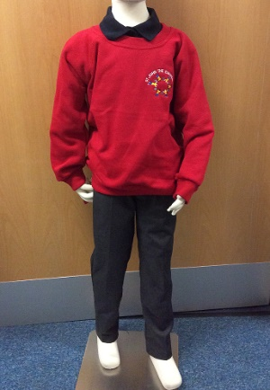 | Girls  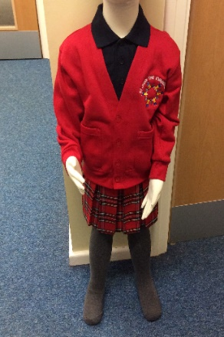
Navy polo shirt (logo optional)  Grey trousers/shorts  Red Sweatshirt (must have logo)  Black pumps (for indoor use)  Black outdoor shoes (No Trainers)  P.E. kit for all children consists of: Navy shorts & Red t- shirt, tracksuit for outdoors and outdoor trainers (year round) – PE kits should be worn on your child’s designated PE days.  PE kit does NOT have to have the school logo on. This can be purchased at your local supermarket or Embroidery In House. | Navy polo shirt (logo optional)  Red Tartan or Grey skirt  Red Tartan or Grey Pinafore  Plain Red or Grey Tights  Grey trousers  Red Sweatshirt/Cardigan (must with logo)  Blue or Red Gingham Dress (summer)  Black pumps (for indoor use)  Black outdoor shoes (No Trainers)

Please, please, please:
Clearly label ALL items of clothing and shoes with your child’s name. School would stress the need to mark your child’s name in each article of clothing. Red sweatshirts are identical – how does your child know which is theirs if it is not clearly marked?
Tie shoulder length hair back – this applies to both girls and boys.
Keep mobile phones at home. Only Year 5 & Year 6 children who walk home are allowed to bring them into school and are handed into the office each day.
Pump bags MUST not be big bulky rucksack, only a small bag please due to limited space.
Send your child’s book bag into school each day. Replacement book bags can be purchased from our uniform providers-Embroidery in House Shop in Clayton.
Please DO NOT:
Send your child into school in ‘designer’ items of clothing.
Send your child into school with extreme hairstyles which have been dyed or coloured or that require styling products. Hair with tramlines and designs shaved into the head are NOT part of our school uniform.
Send your child into school with cosmetic accessories i.e. tooth gems.
Allow your child to bring any toys or games into school unless requested to do so by the class teacher. Any fidgets, makeup, accessories etc brought in will be confiscated and parents will have to collect at the end of the day from the school office (Please note neither the school nor the LEA can accept responsibility for any personal belongings which are lost or damaged at school. All personal clothing and belongings should be clearly marked with the owner’s name).
Send your child into school wearing nail varnish or make-up. All nail varnish and make-up must be removed before coming into school.

Allow your child to wear any items of jewellery – earrings, if worn, should be small studs as hoops can very easily cause damage and injury. Small watches can be worn but necklaces and bracelets must be left at home.

Send your children in shoes which are brightly coloured or with a designer label (no trainers).

Send your child into school with mobile phones, if they are found in school they will be locked in the office until home time, when they will be returned to your child.

Absence from school
If your child is not attending school due to illness, please ring the office on 01274 679030 before 9.00am. There is an automated service for absences.

If we do not hear from you regarding your Childs’ absence we will mark this absence as ‘unauthorised’ until we receive a phone call or message telling us otherwise.

If your child will not be attending school due to having a hospital or doctor’s appointments, we MUST see evidence to support this – this can take the form of an appointment letter/card, prescription or medication. Without this we will not be able to authorise the absence as ‘medical’ – we will have no alternative but to mark the absence as ‘unauthorised’. In ALL circumstances we will only be able to authorise a ‘reasonable’ leave of absence for hospital appointments which considers travelling time – we cannot authorise a full day’s absence for a mid-morning appointment.

We understand there are many reasons for children to miss school and want to work with you to avoid any absences which are unnecessary; however, we would ask you to make all routine, non urgent medical and dental appointments out of school time.

If your child has had any type of vomiting or diarrhea, they must be absent from school for 48 hours after the last episode. This is to ensure that any illnesses are not spread through the school community. We insist on adherence to this policy and if children are sent back to school within the 48-hour period, they will be sent home again.
Attendance

It is essential that your child attends school as often as possible. Children should only be kept off school for valid reasons such as illness, and not for non-valid reasons such as shopping, birthdays etc.

Our Governing Body and Education Bradford have agreed an attendance target of 97% for this academic year. Attendance is monitored each half term, and, as per Education Bradford guidelines, any child whose attendance falls below our attendance target (currently 96%) will receive a letter advising of this. The Government requires schools to publish attendance figures every year.

Our attendance target for the academic year 25/26 was 96%
Our attendance for the academic year 2025/26 is % we are so proud of all children!

Our attendance target for the academic year 2026/27 is 96%.

Please support our school by ensuring your child attends every session possible.
Holidays in Term Time
The school believes that children should not miss school in order to go on holidays in term time and as such holidays should not be booked in term time without prior agreement to authorise such leave. Evidence shows that extended absence from school can be damaging as it can result in insufficient coverage of the national curriculum and children failing to achieve the expected levels.
Parents should, however, be aware that each application will be considered individually considering factors such as the timing of the holiday, a pupils’ attendance record, previous holidays taken, pupil progress and any exceptional circumstances creating the need to take your child out of school
during term time. Please note that taking advantage of a cheap holiday is NOT a mitigating circumstance.

ALL requests for leave of absence MUST be submitted on the link - https://bradford.gov.uk/LOAForm at least 2 weeks prior to the absence advising why you need to take your child out of school and the dates your child will be absent. If you take your child out of school without permission, it will be classed as unauthorised against your child’s attendance record. As per authority guidelines, our school will request that Children’s service issue a Penalty Notice under Section 444 of the Education Act if parents take extended leave in term time without the permission of the school or take additional days in excess of the agreed number of days. The Penalty Notice is £80 per parent per child if paid within 21 days, and £160 per parent per child if paid after but within 28 days.

We must make you aware that if a child has 10 unauthorised absences within a 6 week period, parents/guardians will be asked to attend a meeting in school and this may be followed up by the Education Welfare Officer and a fine.
School Milk
Milk is available for all children in Key Stage 1 and 2 on a daily basis for a charge (Children Under 5 receive milk free until the term in which they are five). Children on Pupil Premium also receive free milk. Letters are sent out before the end of each term with order forms for the following term.
The deadline for purchases for milk for your child is a Tuesday if you order after this day your child will have milk the next following week. If your child is Free School Meals, but does not want milk in school please let the school know as we automatically order milk for all FSM children.
If your child is over 5 years old and does NOT receive FSM, you will be able to pay for milk electronically online via this website Cool Milk

Fruit and Vegetable Scheme
The school takes advantage of the Government Initiative ‘Fruit and Vegetables in School’ which provides each of our children in Reception, Year 1 and Year 2 with a piece of fruit or vegetable each day which is eaten during the morning break.

Behaviour Policy
Our school rules are designed to promote good behaviour by recognizing the importance of praise and rewarding good behaviour.
In school we expect all our children to:
Do what an adult tells you straight away
Listen to the adults and children you meet. They will then listen to you.
Keep hands, feet and objects to yourself.
Speak pleasantly and politely to each other.
Take care of all the things we use.
Walk quietly around school.
The underlying philosophy is based on an agreed whole-school approach to promoting positive behaviour which is achieved by frequent praise, both public and private. Inappropriate behaviour is always taken seriously by the school.

Security around School
All children should arrive and leave through either the Chartwell Drive gate or the Mandale Road gate. The Mandale Road gate will be locked at 9.10am, and the Chartwell Drive gate at 9.10am each day. After 9.10am access into school is through the main entrance on Beacon Road.
The gates will be unlocked at 3pm (at this time the side gate by the dining room will also be unlocked to allow access to the office).
Under no circumstances should the side gate be used by parents and children to leave or enter school via the Beacon Road entrance.

The Beacon Road entrance is for staff, visitors and deliveries only - children and parents must not enter or leave school by that entrance unless they are dropping off or collecting a child outside of normal school hours. This is to ensure the security and safety of everyone.
Parents are kindly reminded that the staff car park is for parents and visitors only.

Parking around School
As with most schools, parking around school can be a sensitive issue. The most sensible place for parents to park is on either Chartwell Drive or Mandale Road and the roads adjoining these roads. There are signs around school indicating where cars CANNOT park at any time and these zones are monitored regularly by the police and Council Parking Wardens who will issue fixed penalties for illegally parked vehicles. Our school is fully committed to working with parents, local police and Bradford Council to ensure ALL our children can travel to and from school safely every day.
For health and safety please do not use the Staff Car Park, nor should you park blocking any drives or on grass verges.

If there are any concerns or complaints regarding parking around school they MUST be raised through the Council website: parkingissues@bradford.go.uk

Please be aware that parking over dipped causeways or on the yellow zig zag lines WILL result in a fine if caught by police, even for Blue Badge holders.

We ask ALL parents/carers to be mindful of not only their own Childs’ safety but also of the safety of ALL school users.

Things we need to know
Medical Information - please ensure that school is informed, in writing, of any allergy or serious medical condition that your child has or develops.
It is essential that the office has up to date contact details to enable us to contact you in case of illness, accident or emergency; such details should include the address, home and work numbers and workplace of parents and persons to be contacted in an emergency. Please let the school office know immediately of any changes.
General Consent: School asks parents to give general permission for a variety of activities including taking children out of school for local events and using photos which members of staff have taken of individuals and groups for purposes such as publicity for the school etc. General permission forms are sent home for parents to sign at the start of your child’s school career at St John the Evangelist and are kept in each child’s record.

Dietary needs – if your child has any food allergies or requirements, please tell us so the information can be passed on to the kitchen. (This does not mean likes/dislikes!)

If anything happens at home which you may feel will affect your child’s learning in school, please let your child’s Class Teacher or the office know, so that we can keep a careful watch on your child during the day.

Arbor App
The Arbor App is used for our texting system, it securely sends text messages and e-mails direct to parents/guardians. If your child is absent you will receive a text message informing you of the absence and requesting you either telephone or e-mail the school to explain this. You will also receive messages informing you of events such as newsletters, parent’s evenings, school closures etc. By sending messages directly to you we can all ensure that if your child is absent you can reply quickly and easily to inform us of any reason for an absence thus ensuring your child’s safety.

Parents/Carers should register for the Arbor app as soon as possible and download the app and sign up with their correct contact details. It is the Parents/Carers responsibility to keep their Arbor account up to date not the school office.

Please see the letter enclosed in the envelope separately regarding the Arbor messaging app.

Medicine in School
Usually when a child is prescribed medication that needs to be taken during school hours they are too ill to be in school. If a child does require medicine in the middle of the school day and has medical advice that they are well enough to take an active part in the whole school day, school will agree with parents/guardians that:
parents/guardians will come into school to administer the medicine, Please speak to the Office to discuss individual cases.

Accidents/First Aid
We have several trained First Aiders/Pediatric First Aiders in school who deal with any accidents. We always contact parents in case of emergencies or illness as soon as possible so please ensure that the first priority contact is always contactable. If your child receives a bump to the head during the school day we will send a text message to inform you and a ‘red’ note home advising you to keep an eye on him/her. If the injury is serious you will be contacted to get your child checked out medically.
Fundraising
Money is raised for our school fund in a variety of ways throughout the school year with the help of all our parents and friends. This money goes towards providing services and items which are not normally provided by the school’s budget but which the Governors and staff feel would benefit all our children. A very important part of our faith and our mission is to support those people less fortunate than ourselves. Throughout Lent and Advent appeals we raise money in a variety of ways to support local and national charities. We do this in fun ways and hope that all parents and children will support our fundraising events.

Complaints Procedure

Our aim is to develop and maintain understanding between the school and all our parents. Whilst we aim to provide a high-quality service to children and parents, we acknowledge that there may be times when you may wish to register a complaint.

In the first instance parents are encouraged to speak to their child’s class teacher with any issues or concerns they may have as soon as they arise, in order that they can be dealt with quickly and efficiently.

If you are not satisfied with the outcome of this discussion you should contact the class teacher and then the Head teacher who will strive to resolve the matter.

If you feel that the matter still has not been resolved, formal complaints should be made in writing to the Head teacher, who will aim to make an initial response within seven working days of the receipt of the complaint.

If you feel that the matter has still not been resolved to your satisfaction, please write to the Governing Body of St John the Evangelist Catholic Primary School giving full details of the complaint. The Complaints Sub-Committee of the Governing Body will meet to discuss the complaint and respond in writing. Please see the complaints policy on our website.

Statutory Information

Parents have the right to see a variety of documents referring to the school’s policy and performance. These include:-

The Governing Body’s statement of curriculum aims.
Our Medicine Policy.
Our Behaviour/ Anti-bullying Policy.
Complaints procedure document.
Our R.E. and Collective Worship Policy.

All of our school policies are on our school website on this link: St John the Evangelist Catholic Primary School - Policies

Holidays
The school calendar, which gives dates of school holidays, is sent to parents periodically throughout the year. The school calendar is also available on our website. Please ensure that family holidays are taken during the holiday periods and not during school time as fines will occur.
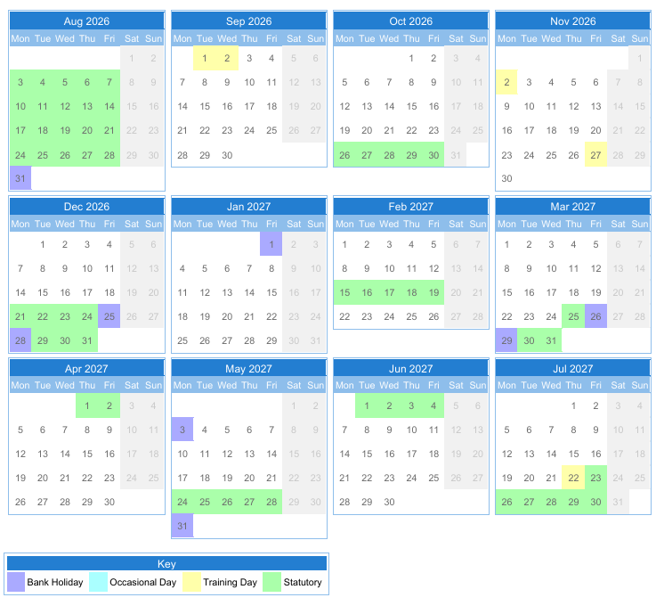
School Calendar 2026/2027

Disclaimer
The information contained in this booklet is correct at the time of publication. It should not be assumed that there will not be changes affecting the information before, or during the next school year.

